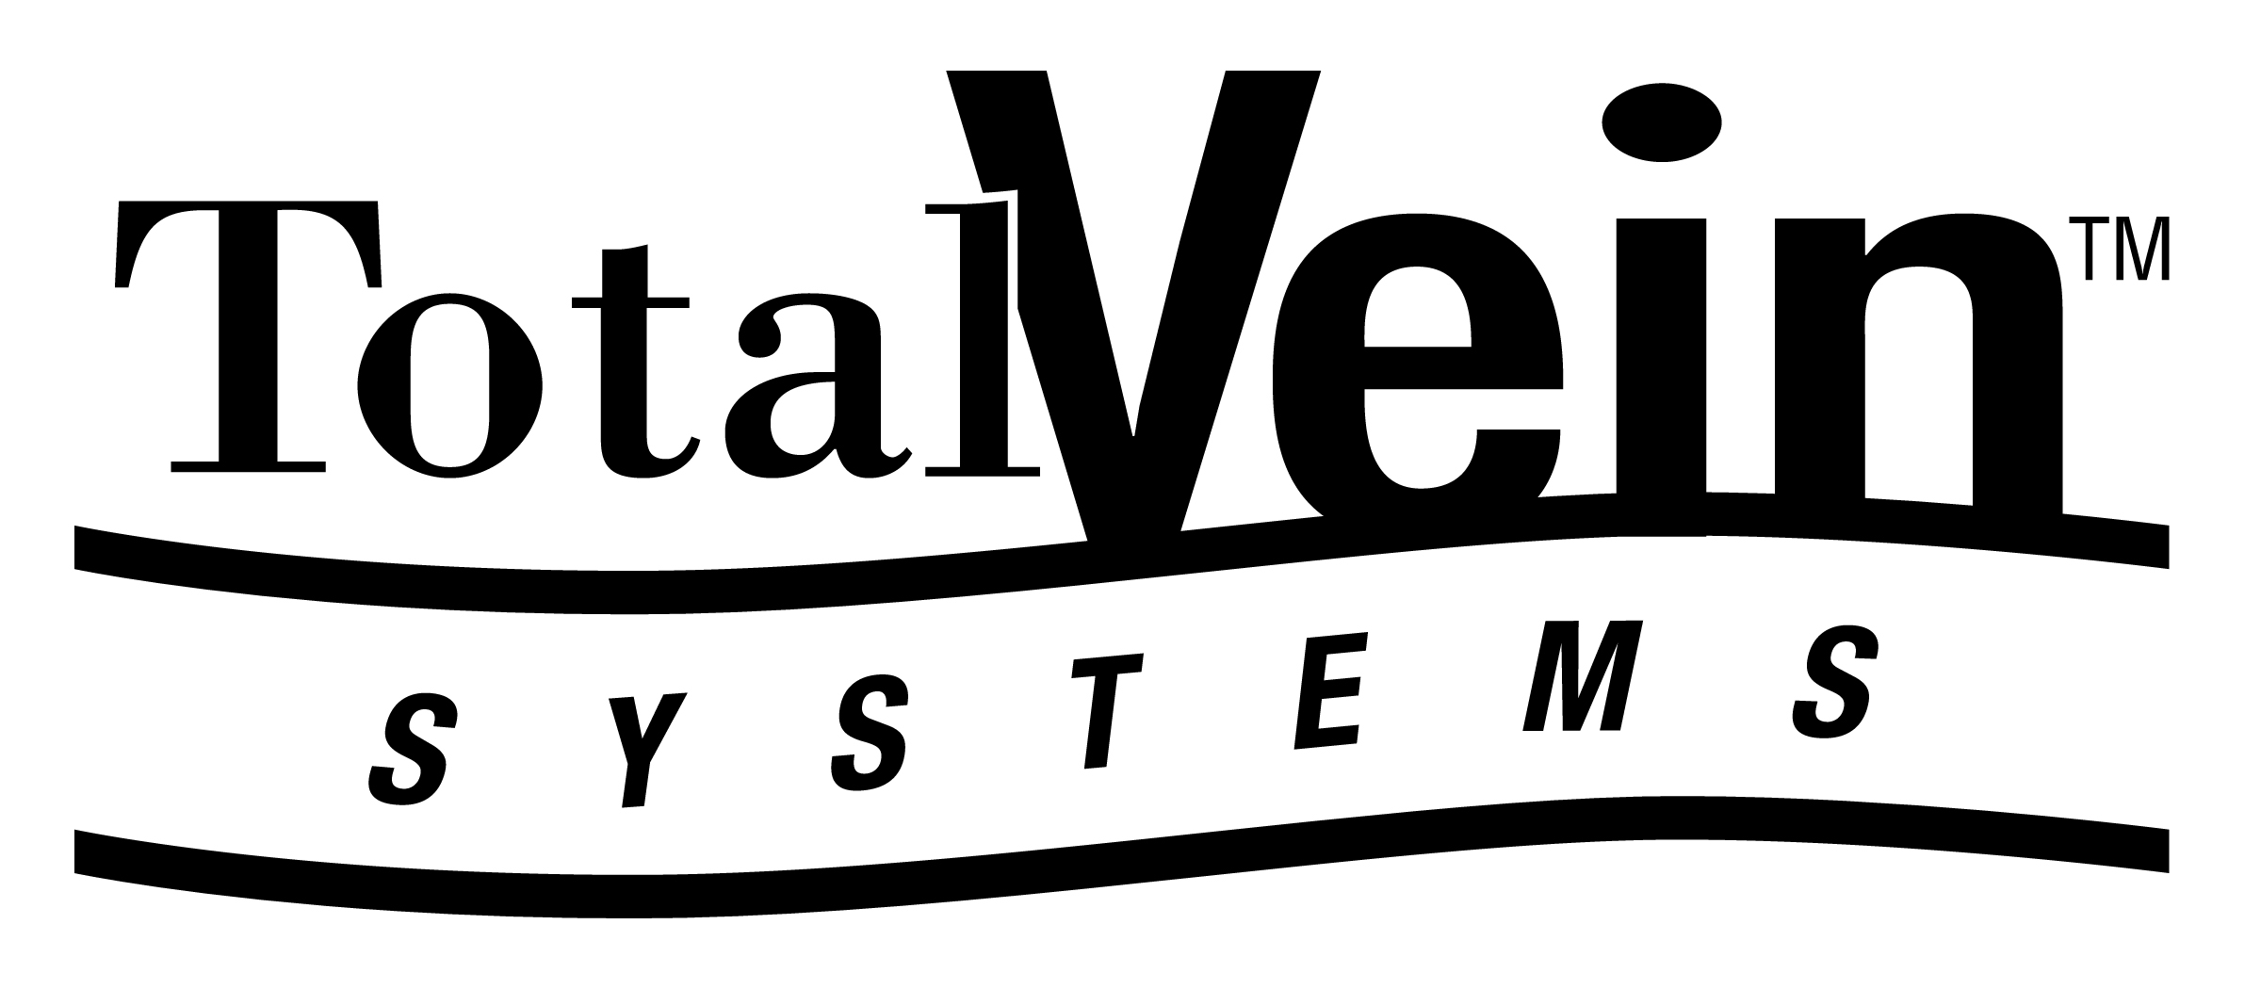
April 25, 2011

Total Vein Systems Looks Forward to Proving Patents Unenforceable Due to
Inequitable Conduct in Upcoming Trial in VNUS Dispute
HOUSTON, Texas (July 30, 2026) - For nearly three years, Total Vein has continued its quest to offer unpatented, disposable medical supplies at reasonable prices, despite the claims of patent infringement made by VNUS Medical Technologies, Inc. In 2008 VNUS Medical Technologies, Inc. (now owned by Tyco Healthcare Group, LP) sued Total Vein; claiming Total Vein’s sales of certain disposable medical supplies infringed five medical method patents. After a seven week trial, in December 2010 a jury returned a verdict finding several of the claims of the asserted patents invalid, but also finding that Total Vein’s sales of certain supplies constituted indirect infringement.
Despite the jury’s verdict, no final judgment awarding VNUS any money has been entered by the Court and many issues remain to be tried on which Total Vein is confident it will prevail.
Still remaining to be heard is a trial on whether the patents should be found unenforceable due to “inequitable conduct” committed by VNUS during the application process for the asserted patents.
Total Vein contends that during the patent application process VNUS failed to disclose certain information to the U.S. Patent and Trademark Office (“USPTO”) that was material to the patentability of the claimed invention, and which if known by the USPTO would have prevented the patents from issuing. The results of the “inequitable conduct” hearing could render the jury’s earlier verdict meaningless. A trial date has not been set, as the parties and the Court have agreed to await the Federal Circuit’s anticipated opinion in Therasense Inc. v. Becton, Dickinson & Co., before conducting this upcoming trial.
Total Vein looks forward to the opportunity to present to the Court evidence substantiating our view that the VNUS patents are invalid and should not be enforced. We intend to continue providing unpatented supplies to medical care providers at affordable prices.

Contact:

David Centanni, General Manager and co-owner
Tyri Schiek, General Manager and co-owner

888 868-8346

